Free Resources

Crisis
 |  | Crisis Open Line:  Address: 402 S 4th Ave, Yakima WA 98902  Phone: (509) 575-4084 / (509) 575-4200/  24 Hour Lines Available 24 hours a day: 1-800-572-8122
 |  | The National Suicide Prevention Lifeline:  Suicide and Crisis Lifeline-Dial 988
 |  | Recovery Help Line:  Phone: 1-866-789-1511
 |  | Children’s protection:  Address: 1002 N 16th Ave, Yakima, WA 98902  Phone: (509) 225-6534
 | 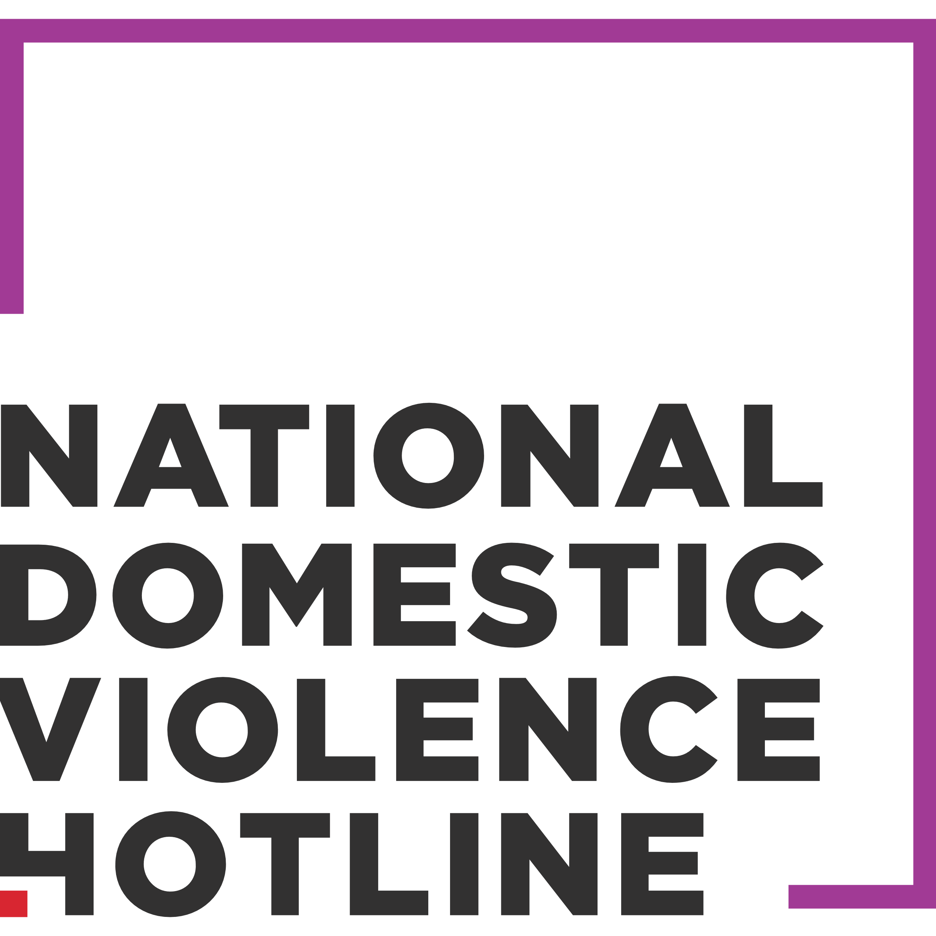    Diaper Bank      Emergency Utility/Rental Assistance    Employment Agencies  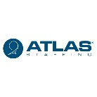        Food        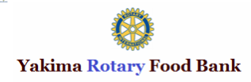    Help with funding for emergency Housing, clothing, Hygiene Supplies:  Housing:    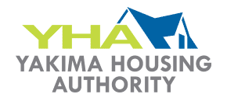  Little to No Cost Clinics:        Schools  Transportation     | 24-Hour Hotline at National Domestic Violence Hotline  Phone: 800-799-SAFE (7233)  Text Start to 88788  Domestic Violence Emergency Shelter at YWCA of Yakima:  Address: 818 W Yakima Ave, Yakima WA 98901 Phone: (509) 248-7796  Diaper Bank at Henry Beauchamp Community Center  Phone: (509) 575-6114  Address: 1211 S 7th Street, Yakima WA 98901  Diaper Bank at Yakima Neighborhood Health Services in Yakima  Phone: (509) 454-4143  Address:12 South 8th Street  Energy Assistance at OIC of Washington on Hathway  Address: 1419 Hathaway Stret, Yakima, WA 98902  Phone: (509) 955-7100  Yakima Nation Rental Program  Phone: (509) 877-6174  Address: 611 South Camas Ave, Wapato, WA 98951  Landlord Tenant Information offered by City of Yakima’s Neighborhood Developmental Services  Phone: (509) 575-6101  Address: 112 South 8th Street, Yakima WA 98901  Description: Offers information regarding housing laws and explains your rights as a landlord or tenant. May also refer to other legal services.  ATLAS Staffing  Phone: (509) 454-7989  Address: 2405 W Washington Suite 100, Yakima, WA 98903  Ellwood Staffing:  Phone: (509) 452-6556  Address: 408 W Chestnut Ave, Yakima, WA 98902  Employment and Training Program:  Phone: (360)-709-4600  Yakima Specialties Inc  Phone: (509) 453-0386  Address: 1819 West J Street, Yakima WA 98902  Meals on Wheels:  Call: (509) 426-2601 or 1-855-426-2601  Apply online or email: lfernandez@pfp.org  Food Pantry at Salvation Army of Yakima  Phone: (509) 453-3139  Address: 9 S 6th Avenue, Yakima WA 98902  Northwest Harvest Fruitvale Community Market  Address: 1819 Fruitvale Blvd, Yakima, WA 98902  Phone: (800) 722-6924  Open Monday, Wednesday and Fridays from 12:00 PM to 6:00 PM  Northwest Harvest Fruitvale Community Market  Phone: (800) 722-6924  Address: 1819 Fruitvale Blvd, Yakima, WA 98902  Open Monday, Wednesday and Fridays from 12:00 PM to 6:00 PM  Food Pantry at Yakima Seventh Day Adventist Church  Phone: (509) 452-2041  Address: 507 N 35th Ave., Yakima, WA 98902  St. Vincent Center  Address: 2629 Main St, Union Gap, WA 98903  Phone: (509) 457-5111  Store Hours:  Monday - Friday: 9am - 7pm  Saturday: 10am - 7pm  The Salvation Army  Phone: (509) 453-3139  Address: 9 S. 6th Ave, Yakima WA 98902  Hours: 509-453-3139  Yakima County Homeless Resource Center, The 107 House  107 S. 6th St, Yakima, WA 98901  (509) 249-6232  Hours. M-F, 9am-12pm & 1-4pm  Transit tickets, utility assistance, clothing, blankets, hygiene supplies, etc.  Camp Hope  Address: 2300 E Birch St, Yakima, WA 98901  Phone: 509-424-1228  Rodʼs House  204 S. Naches Ave., Yakima, WA 98901  (509) 895-2665  Hours M-F, 12:00-4:00pm  Ages 13-24 years old  Showers/laundry facilities, personal hygiene, food, clothing, computer access, mentoring, tutoring,  items for homeless youth. School, medical, shelter, and social service referrals.  Union Gospel Mission  1300 N 1st ST., Yakima, WA 98901  (509) 248-4510  Men, women, families.  Affordable Housing offered by Catholic Charities Housing Services  Phone: (509)853-2800  Address: 5301 Tieton Drive Suite G Yakima WA 98908  Yakima Neighborhood Connections  Phone: (509) 249-6232 Hours: M-F, 8am - 5pm  602 E. Yakima Ave, Yakima, WA, 98901  Yakima Housing Authority  Phone: (509) 453-3106  Address: 1116 Fruitvale Blvd, Yakima WA 98902  Selah Square Apartments Low Income Apartments  303 N Wenas Avenue, Selah, WA, 98942  Phone: (509) 697-7409  Hours: M-F, 9am-3pm  Provides apartments to low income families that meet the qualifications. Water, sewer, and garbage are  paid. There is a laundry facility on site. This is an Equal Housing Opportunity Property.  HousingSearchNW.org Permanent Housing Clearinghouse  (877) 428-8844  M-F, 6am-5pm  Website: http://housingsearchnw.org/  Provides searchable, real-time, listings of available low- and market-rate housing, including senior  housing options. Also provides helpful tools such as a rent checklist, affordability calculator, and links  to other helpful resources.  Commons  The Low Income Apartments 501 W 5th Street, Grandview, WA, 98930  Phone: (509) 882-2867  Hours: Varies  1-bedroom apartments based on 30% of income.  Harmony Park Low Income Apartments  711 Rentschler Lane, Toppenish, WA, 98948  Phone: (509) 865-3117  Hours: Tu/Th, 11am-3pm  Provides apartments to low income families that meet the qualifications.  Next Step Housing Pear Tree Place III  2900 Powerhouse Road Suite 120, Yakima, WA, 98902  Phone: (509) 249-0390  Hours: M-F, 8am-5pm  Website: www.nextstephousing.com  Providing affordable, transitional and permanent housing in the Yakima Valley of Washington State  for homeless veterans & families.  Park Village and Selah Park Apartments Low Income Apartments  554 S 5th Street, Selah, WA, 98942  Phone: (509) 697-9830  Hours: M, Tu, 10am-3pm  Provides apartments to low income families that meet the qualifications. Subsidy may not be available  on move in. Tenants will have to pay full basic rent.  Next Step Housing Sommerset and Pear Tree Place Apartments  2900 Powerhouse Road Suite 120, Yakima, WA, 98902  Phone: (509) 249-0390  Hours: M-F, 9am-5pm  Website: www.nextstephousing.com  Clean and Sober Permanent housing.  Provides Studio, one, two and three bedroom apartments  available in Alcohol and Drug Free communities. Serves adults living with developmental disabilities  and their families. Rents from $287 to $645.  Sandalwood Apartments Low Income Apartments  819 Guyette Lane, Toppenish, WA, 98948  Phone: (509) 865-3117  Hours: Tu, Th, 11am-3pm  Provides apartments to low income families that meet the qualifications  Yakima Valley Farm Workers Clinic  Phone: (509) 248-3334  Address: 602 E Nob Hill Blvd, Yakima, WA 98901  Life Choices Clinic and Care Center  Phone: (509) 248-2273  Address: 305 S. 11th Ave. Suite 1, Yakima, WA 98902  Services included but not limited to:  - Pregnancy testing  - Limited obstetrical ultrasounds  - Options consultations  - Abortion information  - Abortion Pill Reversal  - STI Testing  - Pregnancy support  - Parenting classes and education  - Support for men  - Abortion recovery  - Mental Health Counseling  - Referrals  Birthright of Yakima  Phone: (509) 248-9783  Address: 313 S 11th Ave A, Yakima, WA 98902  Services  - Friendship, love and hope  - Information about:  - Pregnancy  - Childbirth  - Adoption  - Prenatal Care  - Community Programs  - Parenting skills  - Child Care  - Referrals for:  - Public Assistance  - Medical Support  - Financial Resources  - Housing, Legal  - Social Assistance  - Professional Counseling  - Free Resources  - Pregnancy Tests  - Maternity and Baby Items  - Chat online for support  East Valley School District #90  Phone: (509) 573-7347  Address: 2002 Beaudry Rd, Yakima, WA, United States, Washington  Selah School District  Phone: (509) 698-8000  Address: 316 W. Naches Avenue, Selah, WA,  Yakima School District  Phone: (509) 573-7000  Address: 104 N 4th Ave, Yakima, WA  West Valley School District #208  Phone: (509) 972-6000  Address: 8902 Zier Rd, Yakima, WA  Yakima Transit  Address: 104 S. 4th Street  Adults — age 18 and over $1.00  Youth — age 6 to 18 FREE  Reduced fare — Persons 62 and over, or disabled $0.50  Yakima-Ellensburg Commuter – ONE WAY $5.00  Pre-Schoolers — under six with an adult FREE  Transfers (see Transfer policy below) FREE  People for People  Phone: ( 509)248-6793/ Toll Free: 1-800-233-1624  People For People serves communities in nine counties by arranging transportation for people of all ages who are covered under Washington State Apple Health (Medicaid and CHIP) and have a current ProviderOne services card and need transportation to non-emergency medical services. Verification for proper eligibility is confirmed and then the most cost-effective, appropriate transportation is coordinated.

